1.● Use Copilot to generate a is_prime() Python function.
Expected Output#2
● Function to check primality with correct logic.

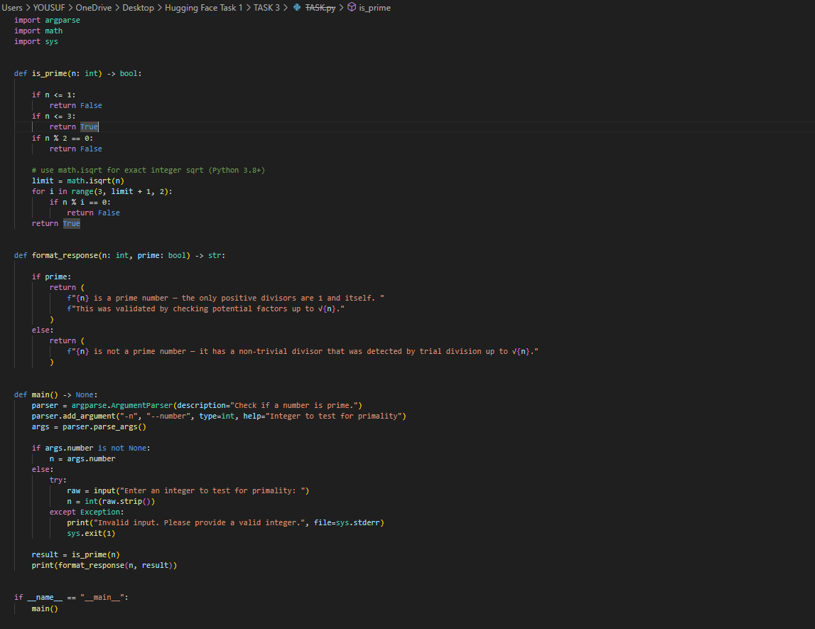
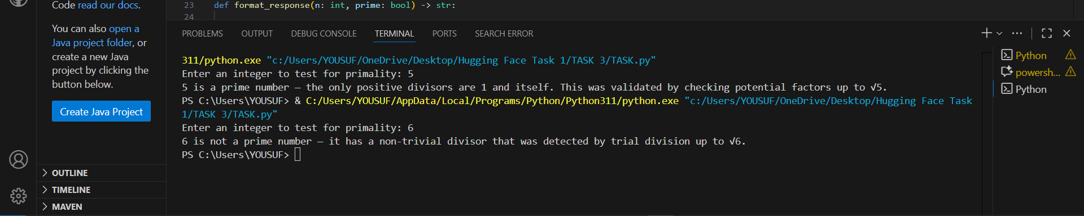

2. Write a comment like # Function to reverse a string and use Copilot to generate the
function.
Expected Output
● Auto-completed reverse function

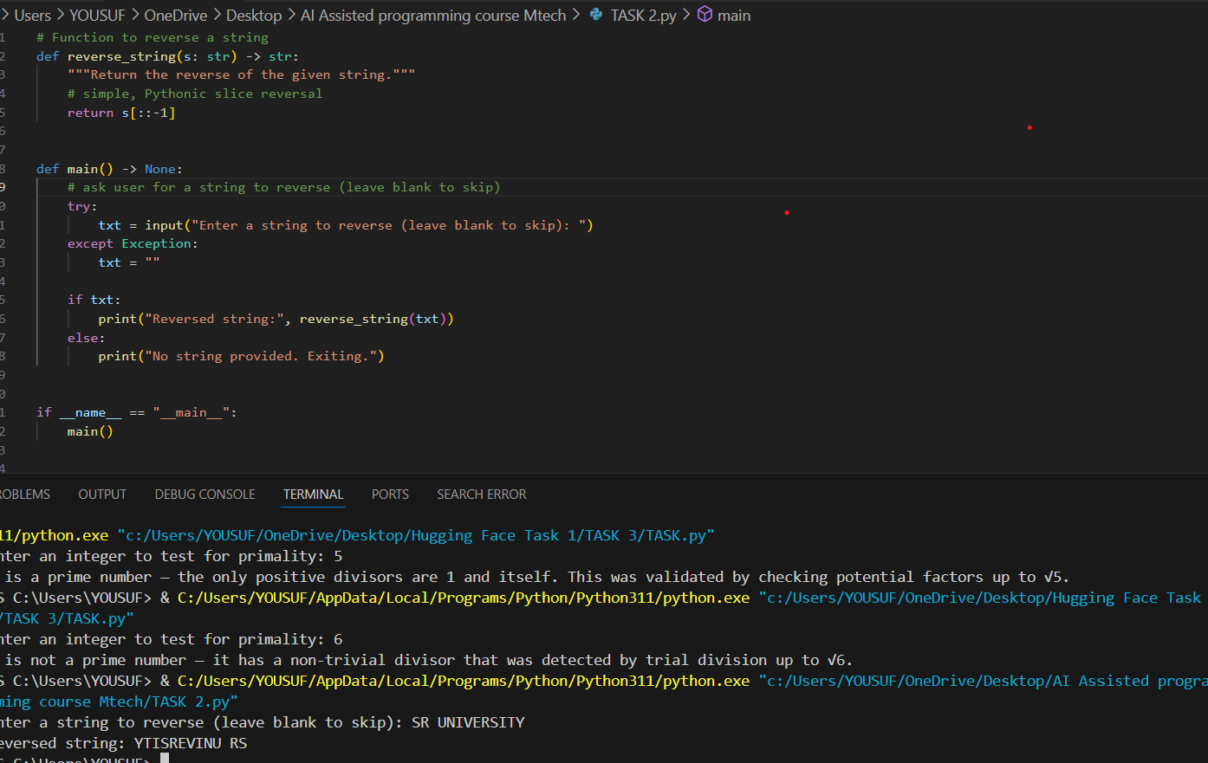

3. Generate both recursive and iterative versions of a factorial function using comments..
Expected Output
● Two working factorial implementations

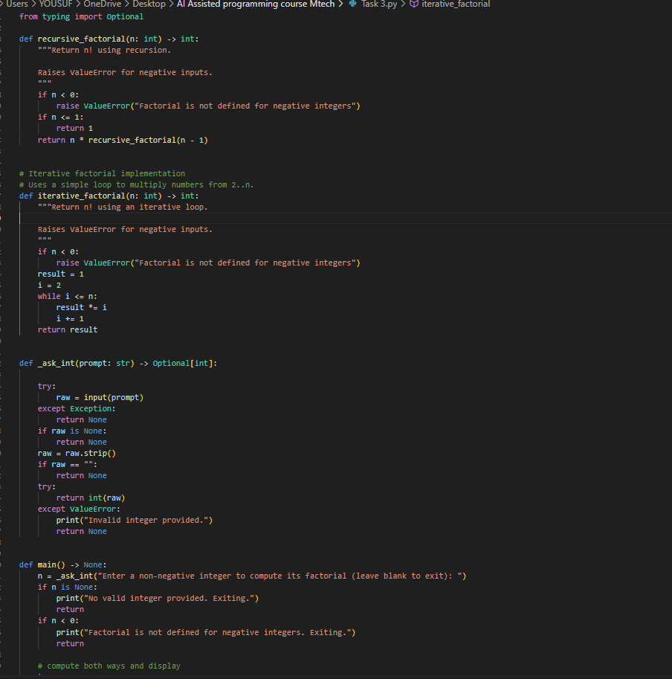

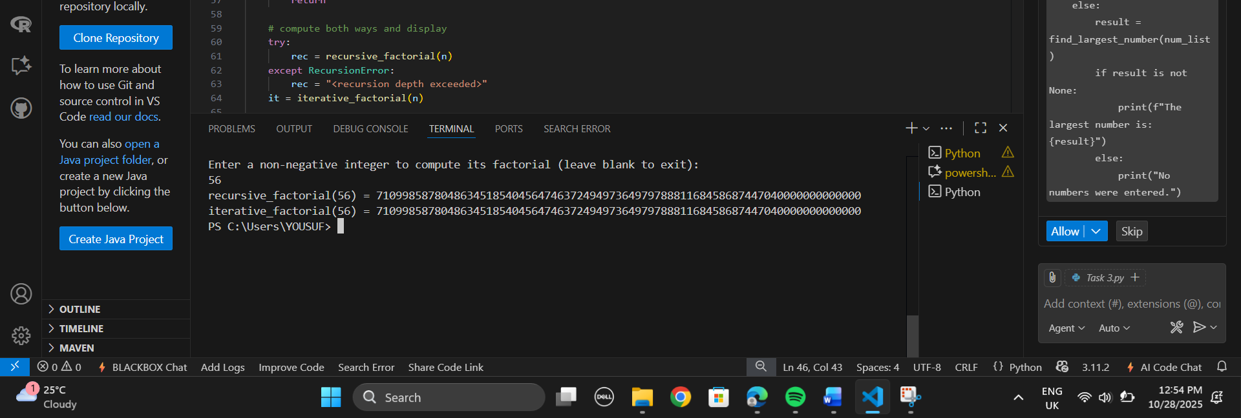

Use Copilot to find the largest number in a list. Assess code quality and efficiency.
Expected Output#5
● A valid function with your review
